Digital Revolution for Dogriffic Clinic

Name of the Student

Name of the University

Authors note

# Q1

For this project the data for the Dogriffic Animal Care is considered which is a small veterinary clinic. The clinic provides clinical care to the domestic companion animals (dogs, cats, birds hamsters and rabbits). The care provider centre is operated by two veterinarians, Augusta and Bernice along with one administrative staff named Cassandra. All the staff works in shifts.

The operational cost includes the insurance amount, utility cost as well as payable to the veterinarians and staff. Following table depicts the cost for running the care institute.

|  |  |  |  |  |  |
| --- | --- | --- | --- | --- | --- |
| **Vets/Staff** | **Day Count** | **Shifthours** | **Shift Hours Every Week** | **Cost/hour** | **Cost/Week** |
| **Augusta** | **3** | **6.5** | **19.5** | **45** | **877.5** |
|  |  |  | **0** |  | **0** |
| **Bernice** | **2** | **6.5** | **13** | **38** | **494** |
|  |  |  | **0** |  | **0** |
| **Cassandra** | **5** | **3.5** | **17.5** | **30** | **525** |
|  |  |  |  |  | **0** |
|  |  |  |  |  | **0** |
| **Replacement worker for Vets($ 49/hour)** |  |  | **32.5** | **49** | **1592.5** |
|  |  |  |  |  | **0** |
| **Replacement worker for Administration worker($39/hour)** |  |  | **17.5** | **39** | **682.5** |
|  |  |  |  |  |  |
| **Cost for Replacement worker every week** |  |  |  |  | **2275** |
|  |  |  |  |  |  |
| **Augusta** | **45630** |  |  |  |  |
|  |  |  |  |  |  |
| **Bernice** | **25688** |  |  |  |  |
|  |  |  |  |  |  |
| **Cassandra** | **27300** |  |  |  |  |
|  |  |  |  |  |  |
| **Replacement Worker** | **9100** |  |  |  |  |
|  |  |  |  |  |  |
| **Total Payment to the vets and Staff** | **107718** |  |  |  |  |
|  |  |  |  |  |  |
|  |  |  |  |  |  |
|  |  |  |  |  |  |
|  |  |  |  |  |  |
| **Insurance Cost** | **16384** |  |  |  |  |
|  |  |  |  |  |  |
| **Utility cost 390/month** | **4680** |  |  |  |  |
|  |  |  |  |  |  |
|  |  |  |  |  |  |
| **Total Operational Cost** | **128782** |  |  |  |  |
|  |  |  |  |  |  |
|  |  |  |  |  |  |
|  |  |  |  |  |  |
| **Required Income for every Month** | **10731.83** |  |  |  |  |

From the above table, it is clear that the annual cost for the care institute is $**128782 and monthly minimum income to cover all the cost is $10731.83.**

For the second condition, in case the two veterinarians were paid at $45/hour and the clinic is closed on Fridays then the Total Operational cost will be reduced to $111024 and the monthly required income will be 9252.

# Q2

In order to find out the number of minimum number of emergency visits the following bar plot is generated from the historical data.

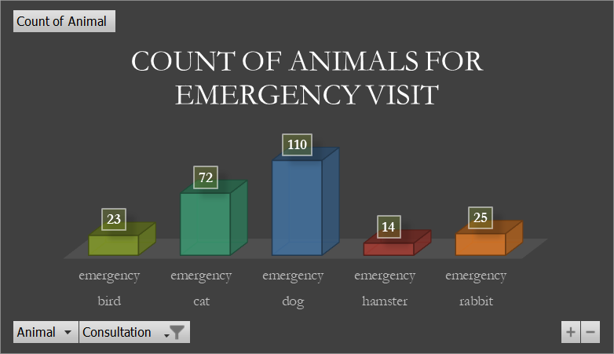

From the above plot, it can be stated that the minimum number of emergency visits are from the hamster owners.

For the number of visits on different days the following horizontal bar plot is created.

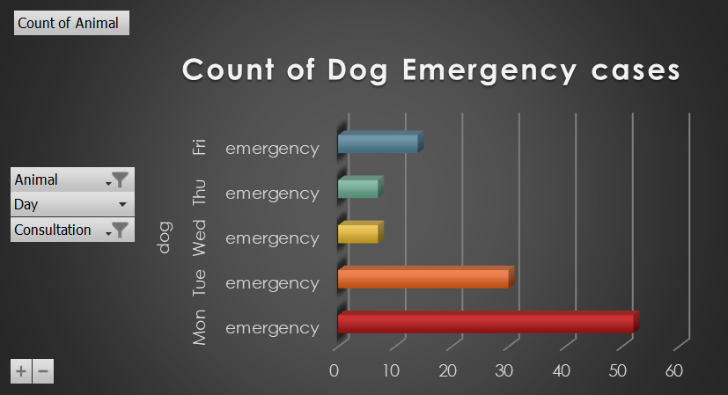

The above plot clearly shows that for the dogs the minimum number of emergency visits are on Wednesdays. Thus for the campaign either Wednesday or Thursday is the best suitable day.

# Q3

In this section, further insights are explored from the historical data.

At first the sum of prices is compared for the different veterinarians Bernice and Augusta.

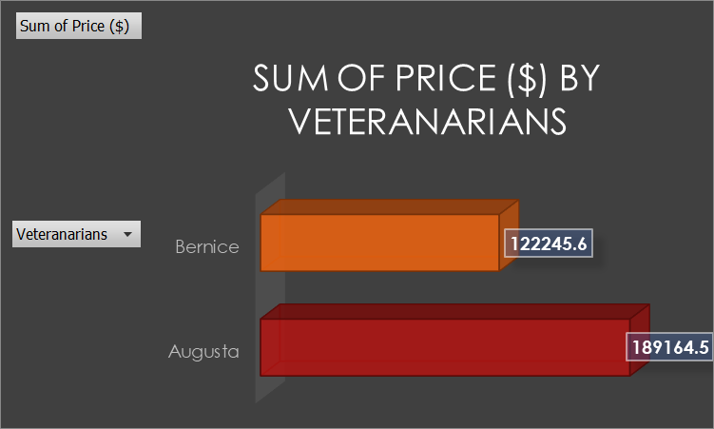

It is evident that, the Augusta generated higher amount of consultation prices for the clinic.

In the next plot, the consultation among the different animals are plotted in the next plot.

From the above plot, it can be stated that highest number of visits for any kind of consultations are recorded for Cats and Dogs compared to other small animals.

Furthermore, the generated total price amount is compared for different months.

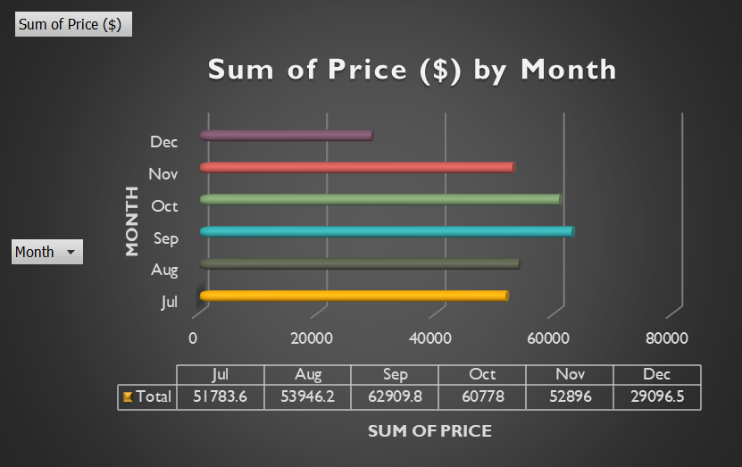

Here, it can be stated that maximum amount is generated in the month of September as it can be seen in the horizontal bar diagram.

In the last plot, the amount on different days are plotted.

The above plot depicts that highest amount of fee is collected on Mondays and Tuesdays and for the emergency visits.

# Q4

For this section, the quoting process for the animal consultation is automated using the inbuilt function of the Excel.

|  |  |  |  |  |
| --- | --- | --- | --- | --- |
| SELECT ANIMAL | hamster |  | SELECT CONSULTATION FOR ANIMAL | checkup |
|  |  |  |  |  |
|  |  |  |  |  |
| PROJECTED PRICE | 55 |  |  |  |
|  |  |  |  |  |

As shown in the above table, the users/staff will be able to choose the type of animal as well as the required consultation type which will consequently prompts projected price for that specific visit depending upon the historical data. For creating the automated table, the AVERAGEIFS, ROUNDUP, DATAVALIDATION functions are utilized. The AVERAGEIFS Function one of the Statistical functions which can calculate average of series of values in a given range of cells (in this case the price column values) depending upon the multiple criteria’s that are selected by the user of the table. ROUNDUP is used in order to increase the projected score to the next integer value.

# Q5

For this part the swim lane BPMN diagram is created using the draw.io tool that can help the staff to better understand the complete process at the clinic and patients.

